## Zscaler Proxy Configuration

### **5.1 Overview of Zscaler Proxy**

Zscaler acts as a cloud-based security proxy that provides secure web access by inspecting traffic between Docker and external services, such as Docker Hub or private registries. It offers security, scalability, and compliance benefits, including:

* Content Filtering: Blocks potentially malicious container images or downloads.
* Authentication and Authorization: Enforces access control policies for users and Docker services.
* Caching & Performance Optimization: Reduces latency by caching frequently accessed images.
* Logging and Reporting: Tracks Docker activity for auditing and compliance.

### **5.2 Steps to Configure Zscaler Proxy for Docker**

#### Step 1: Get Zscaler Proxy Details

1. Log in to your Zscaler admin portal (https://admin.zscaler.net).
2. Navigate to Administration → Cloud Configuration.

Locate the **proxy hostname & port** details. Typically, they follow the format:  
  
proxy.zscaler.net:80

proxy.zscaler.net:443 (for secure HTTPS traffic)

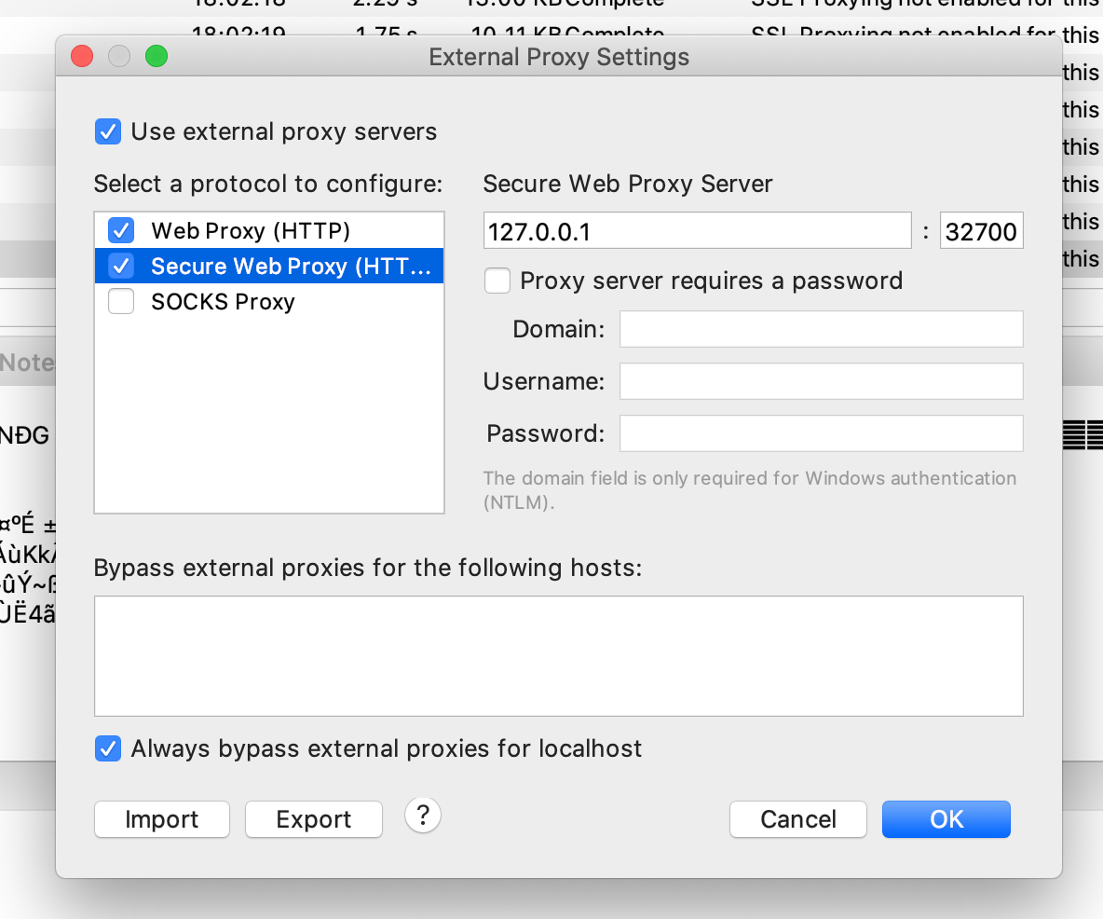

#### Step 2: Configure Docker to Use Zscaler Proxy

Docker needs to be configured to **route requests through Zscaler** by setting environment variables.

Open a terminal and set the proxy variables:  
  
export HTTP_PROXY=http://proxy.zscaler.net:80

export HTTPS_PROXY=http://proxy.zscaler.net:443

export NO_PROXY=localhost,127.0.0.1

To make these settings permanent, add them to your shell profile:

echo "export HTTP_PROXY=http://proxy.zscaler.net:80" >> ~/.bashrc

echo "export HTTPS_PROXY=http://proxy.zscaler.net:443" >> ~/.bashrc

echo "export NO_PROXY=localhost,127.0.0.1" >> ~/.bashrc

source ~/.bashrc

#### Step 3: Update Docker Daemon Configuration

Edit the **Docker daemon.json** file:

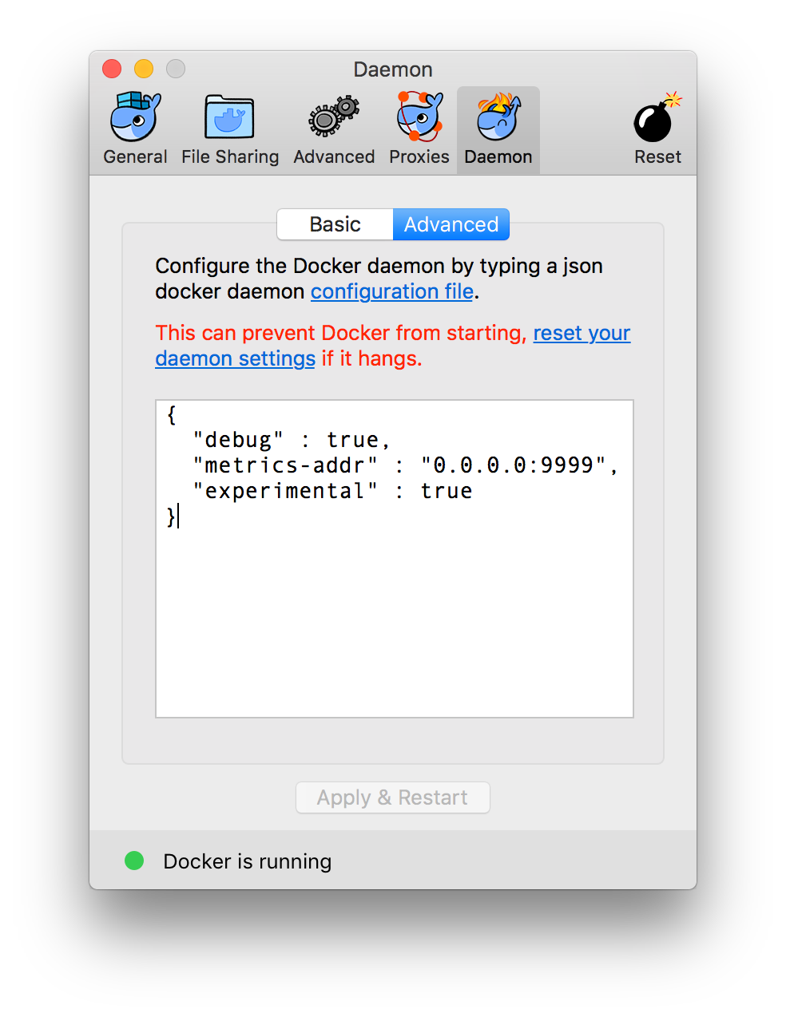

sudo nano /etc/docker/daemon.json

Add the proxy configuration:  
  
{

"proxies": {

"default": {

"httpProxy": "http://proxy.zscaler.net:80",

"httpsProxy": "http://proxy.zscaler.net:443",

"noProxy": ["localhost", "127.0.0.1"]

}

}

}

Save the file (CTRL + X, then Y and Enter).

Restart Docker to apply changes:  
  
sudo systemctl restart docker

#### Step 4: Test Proxy Configuration

Run a simple Docker pull command:  
  
docker pull hello-world

If it succeeds, Zscaler is correctly routing the requests.

#### Step 5: Verify Logging in Zscaler Portal

1. Go to **Zscaler Admin Portal**.
2. Navigate to **Reporting → Web Insights**.
3. Filter logs to check **Docker registry access logs**.